Exploratory Data Analysis of Fatality Time Series
Prepared for: Doug Beirness
Prepared by: Ian McLeod

Contents

1. Summary and Conclusions

2. Variables
(a) total fatalities
(b) bac0 fatalities
(c) bac1 fatalities
(d) bac2 fatalities (key)
(e) bac3 fatalities
(f) bac4 fatalities (key)
(g) noalc fatalities
(h) alc fatalities (key)
(i) ratio = bac4/bac0 (key)
(j) unemploy: unemployment rate
(k) numlicen: number of licensed drivers
(l) rbac2 = bac2/numlicen: fatality rate (key)
(m) rbac4 = bac4/numlicen: fatality rate (key)
(n) ralc = alc/numlicen: fatality rate (key)
(o) rratio = ratio/numlicen: fatality rate (key)

1. Summary and Conclusions

Before constructing a statistical model it is helpful to examine the overall features of the data. In our exploratory analysis we look at tabulations of the all the variables and time series plots. From the time series plots of the key variables (bac2, bac4, alc and ratio) we see that any intervention effect due to the August 1996 0.04 Saskatchewan law, is not obvious and its relative magnitude can not be very large.

The Seasonal Mann-Kendall test provides a test for monotonic trend in a time series and is described in an Appendix: Mann-Kendall Trend Tests. If there is positive autocorrelation the significance levels of the test may be overstated but this effect is quite small unless the autocorrelations are quite large.

One point to note is that there is a sharp downward in the number of licensed drivers in SK in 1989 and it is not until 1996 that the number of licensed drivers returns to its pre-1989 levels. This pattern is very different from that found in the AB and QC data. Presumably it is due to a combination of changes in licensing requirements or some other factors.

Although all variables were examined we will only comment on the key variables.

For the key dependent variables, I decided to use the rate per 100,000 licensed drivers. Alternatively we could include the number of licensed drivers as an independent variable in the regression and work with the original variable. The adjusted key dependent variables

rbac2 fatalities
There is strong evidence of a downward monotonic trend in SK, AB and QC. The downward slope is larger in AB than SK and again larger in QC than AB. QC has the lowest rate but the AB rate is only slightly higher than SK. There is no evidence though of autocorrelation in the SK fatalities. This suggestions that ordinary multiple linear regression may be used. A Poisson regression using bac2 regressed on the number of drivers could also be used but I don’t think the conclusions would change since in this situation the assumptions of multiple linear regression are robust enough.

rbac4 fatalities and ralc fatalities
There is strong evidence of a downward monotonic trend in SK, AB and QC. The downward slope is larger in AB than SK and again larger in QC than AB. There is a small degree of positive autocorrelation in rbac4 and ralc for SK which indicates that a regression or intervention analysis taking into account an autocorrelated error term will be necessary for valid statistical inferences. Once again, QC has the lowest rate but the AB rate is only slightly higher than SK.

rratio fatalities
There is strong evidence of a downward monotonic trend in SK, AB and QC. The downward slope is slightly larger in AB than SK. QC has the much stronger downward tend than AB or SK. There is no significant autocorrelation in SK rratio fatalities which suggests that ordinary multiple linear regression will be sufficient. Comparison among the provinces indicates that for rratio SK is slightly larger than AB and much larger than QC.

In the case of rratio the statistical software R
(http://cran.us.r-project.org/)
was used to compute the autocorrelation since this software handles missing values correctly.

2. Variables

(a) Total Fatalities

Saskatchewan: Total Fatalities

The overall trend is downward. Signficant at 0.00086 on a two-sided test.

> deathsSK
Jan Feb Mar Apr May Jun Jul Aug Sep Oct Nov Dec
1987: 6 8 9 5 15 19 12 17 11 10 12 12
1988: 8 7 8 9 10 16 14 13 6 15 6 9
1989: 12 6 8 12 13 8 14 13 14 20 7 7
1990: 5 9 5 2 10 14 12 10 14 15 8 3
1991: 2 5 9 8 13 10 11 12 10 8 6 9
1992: 7 4 8 10 8 5 8 8 6 8 6 5
1993: 5 4 9 14 8 8 14 8 8 12 7 8
1994: 8 3 1 4 10 8 21 11 6 14 5 7
1995: 10 6 6 2 7 14 12 16 6 9 4 7
1996: 7 5 5 4 5 8 4 10 13 4 4 11
1997: 4 5 8 4 10 8 6 3 8 6 8 13
1998: 3 10 3 10 13 5 14 5 6 6 8 7
1999: 6 7 7 16 11 9 4 7 8 14 12 9
2000: 7 4 4 10 11 5 13 9 6 7 7 7
2001: 7 4 6 6 8 15 10 14 12 9 13 5
> SeasonalMannKendall(deathsSK)
tau = -0.192, sl =0.08632%

Alberta: Total Fatalities

The overall trend is downward and it is statistically significant at about 0.0003 on a two-sided test.

> deathsAB
Jan Feb Mar Apr May Jun Jul Aug Sep Oct Nov Dec
1987: 17 12 21 25 37 31 26 34 30 22 35 18
1988: 13 16 25 30 20 25 36 37 32 32 17 25
1989: 15 20 14 18 22 20 38 32 34 30 27 26
1990: 19 12 20 16 18 20 26 31 28 20 19 18
1991: 15 20 18 11 24 16 33 32 25 17 21 18
1992: 14 9 18 18 17 24 18 29 22 16 16 23
1993: 15 13 12 11 15 21 20 26 25 27 28 22
1994: 18 12 12 15 26 23 26 21 31 18 24 20
1995: 18 15 12 22 23 17 22 23 24 31 19 14
1996: 17 9 16 16 13 18 22 27 17 19 17 26
1997: 12 11 28 22 20 18 23 30 21 28 26 31
1998: 15 17 15 16 27 23 21 25 21 25 28 29
1999: 15 11 23 9 26 24 15 20 16 21 23 23
2000: 17 11 14 13 13 18 28 18 23 18 25 18
2001: 23 13 14 20 20 28 19 34 24 20 17 11
> SeasonalMannKendall(deathsAB)
tau = -0.203, sl =0.03318%

Quebec: Total Fatalities

The overall trend is downward and it is statistically significant at about 10⁻¹² on a two-sided test.

> deathsQC
Jan Feb Mar Apr May Jun Jul Aug Sep Oct Nov Dec
1987: 33 22 19 43 71 68 69 77 53 67 52 56
1988: 43 22 32 36 58 83 83 74 43 58 49 50
1989: 35 49 40 49 60 63 95 70 67 57 57 53
1990: 30 36 48 48 58 91 75 71 69 53 43 33
1991: 43 44 42 35 68 75 71 68 43 49 49 36
1992: 42 40 25 33 58 66 48 55 40 49 43 70
1993: 37 39 32 34 44 71 75 56 49 49 28 41
1994: 44 29 23 28 44 46 56 53 54 66 34 37
1995: 41 35 27 30 48 59 53 61 48 43 52 30
1996: 42 37 35 17 50 45 60 72 32 53 55 41
1997: 37 22 20 29 29 54 50 66 38 43 51 32
1998: 34 26 25 34 38 38 44 50 39 46 39 44
1999: 31 32 31 38 46 47 53 53 43 39 48 44
2000: 32 35 23 31 52 42 48 60 50 43 31 35
2001: 31 30 25 24 38 48 35 53 37 26 19 38
> SeasonalMannKendall(deathsQC)
tau = -0.427, sl =2.82e-12%

Time Series Plots of Total Fatalities

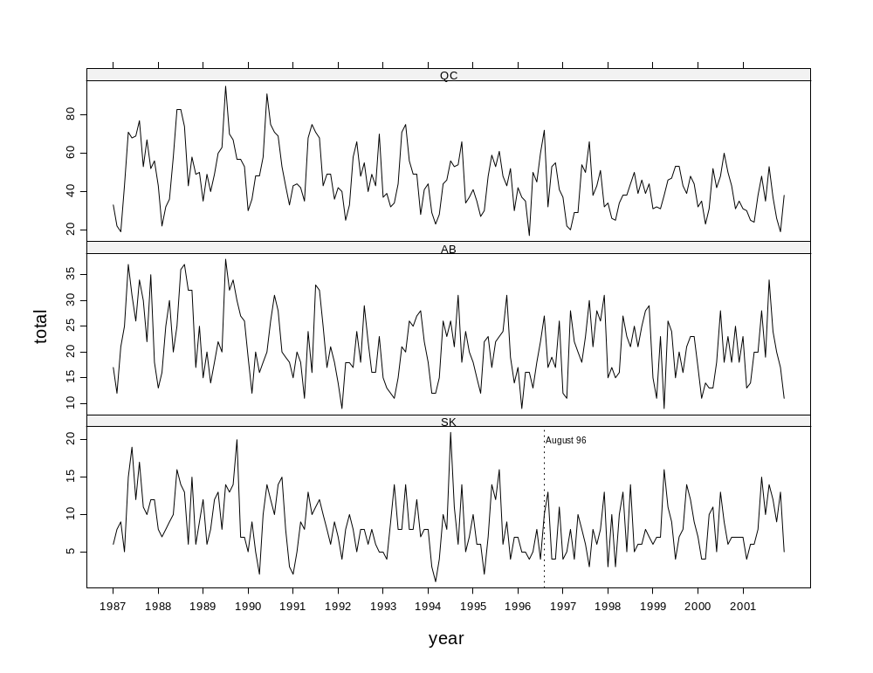

Autocorrelation Analysis

All series show moderate autocorrelation at lags 1 and 12.

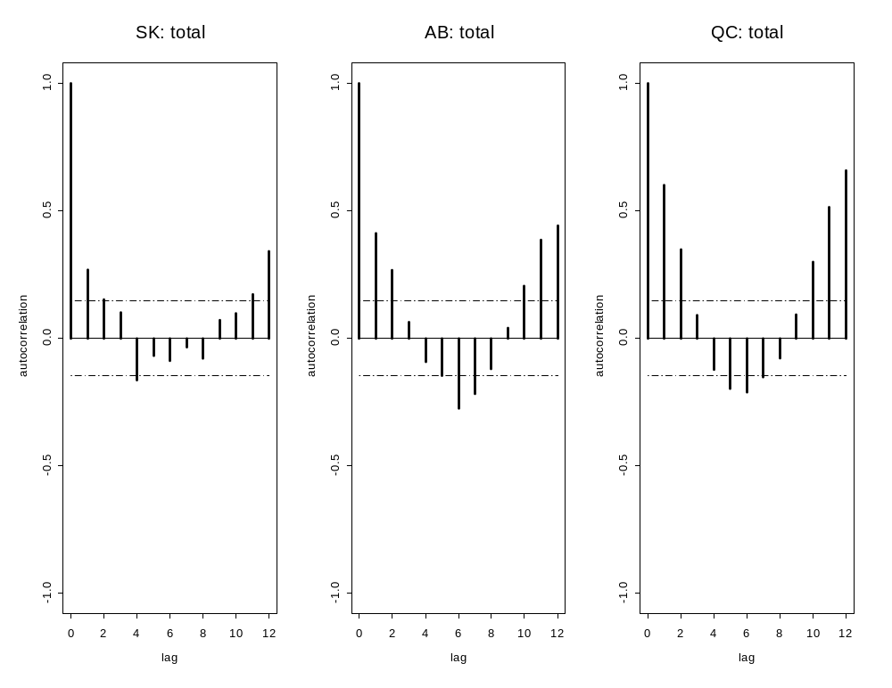
(b) bac0 Fatalities

Saskatchewan: Total Fatalities

No monotonic trend.

> deathsSK <- ts(fatal.df$bac0[fatal.df$province == "SK"], freq = 12, start = 1987)
> deathsSK
Jan Feb Mar Apr May Jun Jul Aug Sep Oct Nov Dec
1987: 3 1 4 1 5 6 5 5 4 4 3 1
1988: 2 4 6 2 1 7 8 4 3 6 5 7
1989: 9 2 5 2 5 5 6 4 5 9 2 4
1990: 2 4 1 2 6 6 4 5 6 8 4 2
1991: 0 4 4 3 5 3 5 6 2 3 2 6
1992: 4 3 4 6 4 3 3 3 2 2 3 2
1993: 4 3 4 9 5 3 7 3 2 7 5 4
1994: 7 2 1 0 6 6 14 4 2 6 4 3
1995: 5 4 1 1 4 6 7 8 4 2 4 5
1996: 3 2 2 3 4 2 2 3 6 2 4 9
1997: 4 3 4 2 3 3 3 2 5 4 5 7
1998: 2 6 2 4 7 5 9 2 4 3 5 3
1999: 3 4 5 4 4 5 0 5 3 6 5 6
2000: 6 2 3 7 7 3 5 4 2 3 4 5
2001: 1 3 3 3 4 8 3 6 6 4 3 4
> SeasonalMannKendall(deathsSK)
tau = 0.00343, sl =95.32%

Alberta: Total Fatalities

No monotonic trend.

deathsAB <- ts(fatal.df$bac0[fatal.df$province == "AB"], freq = 12, start = 1987)
> deathsAB
Jan Feb Mar Apr May Jun Jul Aug Sep Oct Nov Dec
1987: 9 8 11 13 16 9 17 20 15 6 18 4
1988: 8 10 11 8 10 16 14 21 18 17 2 12
1989: 7 13 7 7 9 8 16 16 16 13 14 20
1990: 14 9 10 10 5 11 12 13 12 12 13 10
1991: 7 11 9 6 7 10 17 13 12 8 17 9
1992: 4 5 9 7 6 15 9 13 14 8 8 14
1993: 10 7 10 7 8 9 14 18 13 13 15 16
1994: 15 7 7 9 17 16 14 12 17 10 15 14
1995: 13 10 4 17 14 11 14 13 15 14 16 10
1996: 12 6 9 11 6 5 13 17 10 10 12 17
1997: 9 9 19 15 11 7 11 22 12 21 16 17
1998: 11 13 12 10 13 14 11 18 12 11 16 15
1999: 11 9 16 7 15 14 7 9 11 16 13 14
2000: 0 12 8 5 9 8 19 10 13 7 18 14
2001: 17 8 6 10 13 18 9 19 13 10 10 7
> SeasonalMannKendall(deathsAB)
tau = -0.0328, sl =56.39%

Quebec: bac0 Fatalities

Monotonic trend present. Significant at 0.0013 on a two-sided test.

deathsQC <- ts(fatal.df$bac0[fatal.df$province == "QC"], freq = 12, start = 1987)
> deathsQC
Jan Feb Mar Apr May Jun Jul Aug Sep Oct Nov Dec
1987: 7 4 2 3 9 6 15 10 7 6 11 16
1988: 14 7 8 9 12 16 26 16 6 21 12 16
1989: 16 15 12 17 17 14 26 24 16 14 13 16
1990: 9 16 17 12 7 29 22 23 21 23 19 15
1991: 20 22 10 10 15 14 24 20 14 12 17 16
1992: 19 16 11 10 19 20 16 26 13 22 15 35
1993: 27 19 20 12 13 31 33 25 20 27 18 19
1994: 22 13 9 13 20 19 22 25 18 20 10 15
1995: 26 17 16 9 19 23 20 23 19 17 27 11
1996: 23 19 19 6 18 21 20 35 13 23 19 15
1997: 18 9 15 8 9 18 13 26 13 19 24 16
1998: 12 11 8 16 12 17 24 18 17 15 16 18
1999: 18 16 15 19 26 28 27 24 26 22 27 17
2000: 15 19 12 15 26 22 17 28 23 24 14 14
2001: 18 13 13 8 14 21 20 26 15 9 6 18
> SeasonalMannKendall(deathsQC)
tau = 0.182, sl =0.1272%

Time Series Plots of bac0 Fatalities

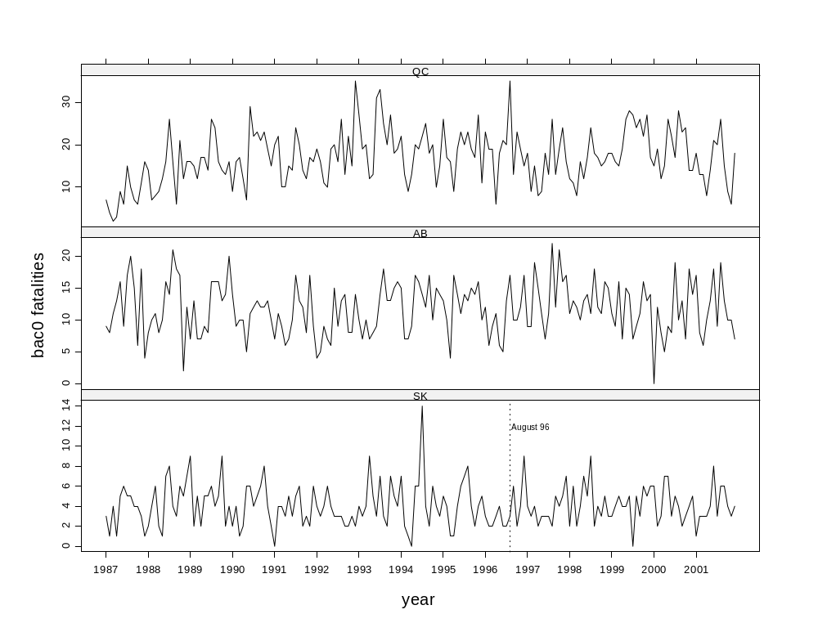

Autocorrelation Analysis

SK shows no significant autocorrelation but small positive autocorrelations are present at lags 1 and 12. AL very small autocorrelations at lags 1 and 12. QC shows moderate autocorrelation at lags 1 and 12.

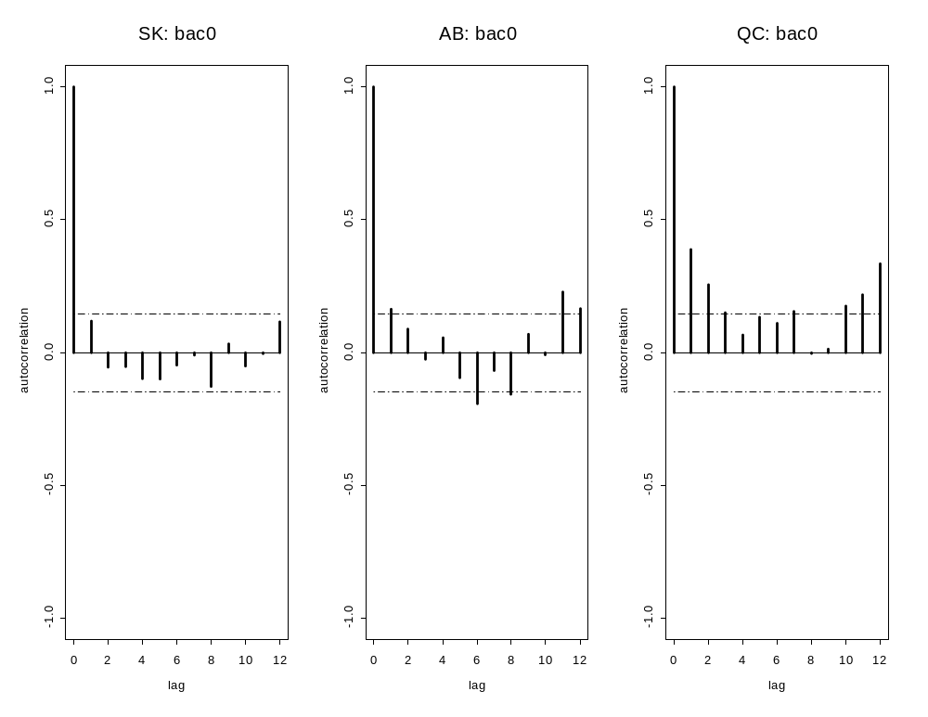
(c) bac1 Fatalities

Saskatchewan: bac1 Fatalities

> deathsSK <- ts(fatal.df$bac1[fatal.df$province == "SK"], freq = 12, start = 1987)
> deathsSK
Jan Feb Mar Apr May Jun Jul Aug Sep Oct Nov Dec
1987: 0 0 0 0 0 0 0 0 0 1 0 1
1988: 2 0 0 0 1 1 0 1 0 1 0 0
1989: 1 0 0 0 0 0 2 0 0 1 0 1
1990: 0 0 0 0 1 1 0 0 1 1 0 1
1991: 0 1 1 0 1 0 2 1 0 1 0 1
1992: 0 0 0 0 0 0 1 0 0 0 0 0
1993: 0 0 1 0 0 0 2 0 0 1 0 0
1994: 0 0 0 0 0 2 1 1 1 0 0 2
1995: 4 0 0 0 0 1 0 1 0 0 0 0
1996: 0 0 0 0 0 0 0 2 1 0 0 0
1997: 0 0 0 0 1 1 0 0 0 0 0 0
1998: 0 0 0 0 0 0 0 0 0 0 0 0
1999: 0 0 0 0 0 0 0 0 1 2 0 0
2000: 0 0 0 0 0 0 1 0 0 0 1 0
2001: 1 0 0 0 2 0 0 0 1 0 1 0

Too many zeros for Seasonal Mann-Kendall trend test.

Alberta: bac1 Fatalities

No monotonic trend.

deathsAB <- ts(fatal.df$bac1[fatal.df$province == "AB"], freq = 12, start = 1987)
> deathsAB
Jan Feb Mar Apr May Jun Jul Aug Sep Oct Nov Dec
1987: 0 1 1 0 1 1 1 0 1 0 2 0
1988: 0 0 0 5 0 1 1 3 0 1 1 0
1989: 2 0 0 0 0 1 2 0 1 0 0 0
1990: 0 1 0 0 0 1 0 1 2 0 0 1
1991: 0 0 0 0 1 1 1 2 0 0 0 0
1992: 1 0 0 2 1 3 1 1 0 1 0 0
1993: 0 0 0 0 1 2 1 3 2 1 1 0
1994: 0 0 0 1 0 0 0 1 1 0 0 1
1995: 1 1 0 1 0 1 0 0 3 0 0 0
1996: 0 1 0 1 3 2 0 0 0 1 1 2
1997: 0 0 1 0 0 2 1 0 1 1 1 2
1998: 0 0 0 0 1 0 1 1 0 1 3 0
1999: 0 1 1 0 0 2 0 2 0 0 0 0
2000: 0 0 0 1 0 1 0 0 3 1 1 1
2001: 0 0 0 1 0 1 0 1 0 0 0 0
> SeasonalMannKendall(deathsAB)
tau = -0.0424, sl =50.2%

Quebec: bac1 Fatalities

Overall negative monotonic trend downwards. Significant at 0.0001 on a two-sided test.

deathsQC <- ts(fatal.df$bac1[fatal.df$province == "QC"], freq = 12, start = 1987)
> deathsQC
Jan Feb Mar Apr May Jun Jul Aug Sep Oct Nov Dec
1987: 5 2 1 9 2 8 6 8 3 2 1 0
1988: 1 2 2 1 3 1 2 3 1 2 2 1
1989: 0 1 0 2 0 3 2 1 1 1 0 2
1990: 1 1 3 3 2 2 4 1 2 3 0 0
1991: 0 3 1 1 3 1 2 0 1 3 0 0
1992: 4 2 1 0 3 3 1 3 1 2 0 3
1993: 1 1 0 1 0 3 2 1 3 0 3 1
1994: 5 1 2 0 3 0 3 1 2 4 3 0
1995: 2 1 1 2 2 2 1 2 1 0 0 2
1996: 1 2 0 0 1 0 5 0 0 4 1 1
1997: 1 2 0 1 0 0 2 2 1 0 1 1
1998: 1 0 0 0 1 2 0 0 1 1 1 2
1999: 1 0 2 0 0 3 1 1 0 0 0 1
2000: 1 0 2 0 1 1 2 1 2 1 0 1
2001: 2 0 0 1 4 3 0 0 1 3 0 0
> SeasonalMannKendall(deathsQC)
tau = -0.23, sl =0.01269%

Time Series Plots of bac1 Fatalities

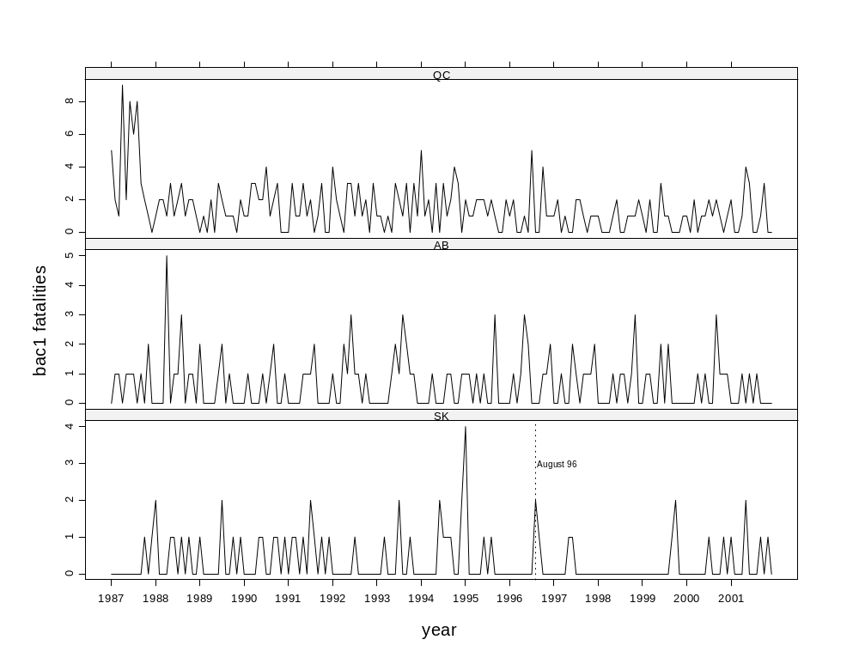

Autocorrelation Analysis

SK and AB no autocorrelation. QC moderate autocorrelation at low lags. No seasonal autocorrelation in any series.

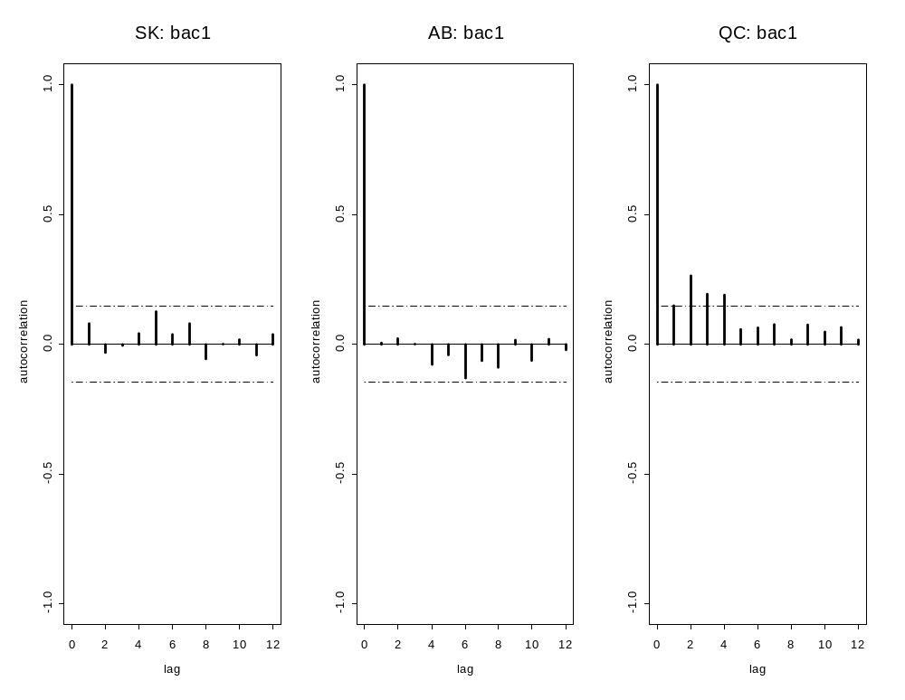
(d) bac2 Fatalities

Saskatchewan: bac2 Fatalities

The overall trend is downward but it is only statistically significant on a one-sided test at the 3% level.

> deathsSK <- ts(fatal.df$bac2[fatal.df$province == "SK"], freq = 12, start = 1987)
> deathsSK
Jan Feb Mar Apr May Jun Jul Aug Sep Oct Nov Dec
1987: 0 3 0 0 1 1 0 0 1 0 1 0
1988: 1 0 0 1 0 1 1 2 1 2 0 0
1989: 0 0 0 0 0 0 0 1 2 1 0 0
1990: 0 0 0 0 0 1 0 0 0 0 0 0
1991: 0 0 0 0 0 0 2 0 2 0 1 0
1992: 0 0 2 1 0 0 0 1 0 0 0 0
1993: 0 0 0 1 0 0 1 1 0 1 0 0
1994: 0 0 0 0 0 0 1 1 1 1 0 1
1995: 0 0 0 0 0 1 1 0 0 1 0 0
1996: 1 0 0 0 0 0 0 0 0 0 0 0
1997: 0 0 0 0 1 0 0 0 0 1 1 0
1998: 1 0 0 0 0 0 0 0 1 0 0 0
1999: 0 1 0 1 0 0 0 0 1 1 1 0
2000: 0 0 0 0 0 0 1 0 0 0 0 0
2001: 0 0 0 1 0 0 1 2 0 0 0 0
> SeasonalMannKendall(deathsSK)
tau = -0.122, sl =6.331%

Alberta: bac2 Fatalities

The overall trend is downward and it is statistically significant at about 4% on a one-sided test.

deathsAB <- ts(fatal.df$bac2[fatal.df$province == "AB"], freq = 12, start = 1987)
> deathsAB
Jan Feb Mar Apr May Jun Jul Aug Sep Oct Nov Dec
1987: 0 0 1 1 1 4 1 0 0 2 2 0
1988: 0 1 0 2 1 0 2 1 1 1 0 0
1989: 0 2 0 0 1 0 0 0 0 1 2 0
1990: 0 1 0 1 3 1 1 3 1 1 0 0
1991: 0 1 1 0 2 1 1 2 0 0 1 0
1992: 1 1 0 1 2 0 1 0 1 1 1 2
1993: 2 1 0 0 0 2 0 0 0 0 2 0
1994: 1 0 0 0 1 1 0 1 1 1 0 1
1995: 1 0 1 0 0 0 1 1 0 0 0 0
1996: 0 1 0 0 1 0 0 0 0 0 0 0
1997: 0 0 0 0 1 1 1 1 1 0 0 1
1998: 0 2 2 2 2 2 0 0 1 0 1 0
1999: 0 0 0 0 2 1 1 0 0 0 0 1
2000: 0 0 0 0 0 0 1 2 0 1 1 0
2001: 2 0 0 1 2 0 1 1 0 1 0 0
> SeasonalMannKendall(deathsAB)
tau = -0.111, sl =7.815%

Quebec: bac2 Fatalities

The overall trend is downward and it is statistically significant at about 1.8% on a two-sided test.

deathsQC <- ts(fatal.df$bac2[fatal.df$province == "QC"], freq = 12, start = 1987)
> deathsQC
Jan Feb Mar Apr May Jun Jul Aug Sep Oct Nov Dec
1987: 0 0 0 0 2 3 0 2 2 3 1 2
1988: 1 0 1 2 2 2 3 3 0 2 1 1
1989: 0 1 0 1 4 4 2 1 2 2 0 1
1990: 0 1 1 3 3 2 3 1 3 2 0 2
1991: 3 2 2 1 3 3 0 1 1 0 1 1
1992: 0 2 0 1 1 2 0 1 0 0 1 1
1993: 0 2 0 1 1 2 0 1 1 2 0 0
1994: 0 0 1 0 2 2 0 0 0 2 1 0
1995: 2 1 1 2 0 2 2 1 1 0 2 2
1996: 0 0 1 1 0 0 0 1 0 2 1 0
1997: 0 0 0 1 0 1 1 4 2 0 1 1
1998: 2 1 2 0 1 2 0 1 0 0 1 0
1999: 0 0 0 2 2 1 4 2 0 2 1 2
2000: 0 0 1 3 2 2 2 2 1 1 2 1
2001: 0 0 0 1 0 2 2 0 1 0 0 1
> SeasonalMannKendall(deathsQC)
tau = -0.146, sl =1.767%

Time Series Plots of bac2 Fatalities

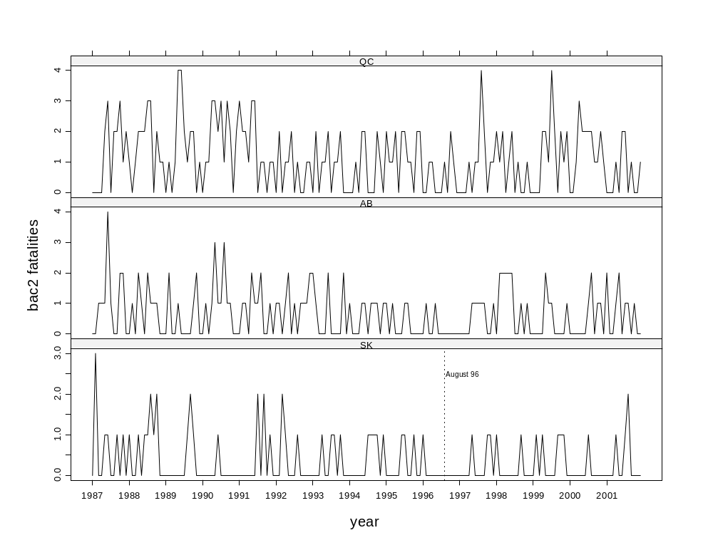

Autocorrelation Analysis

SK shows no significant autocorrelation. AL very small autocorrelations at lag 1. QC shows small autocorrelation at lags 1 and 12.

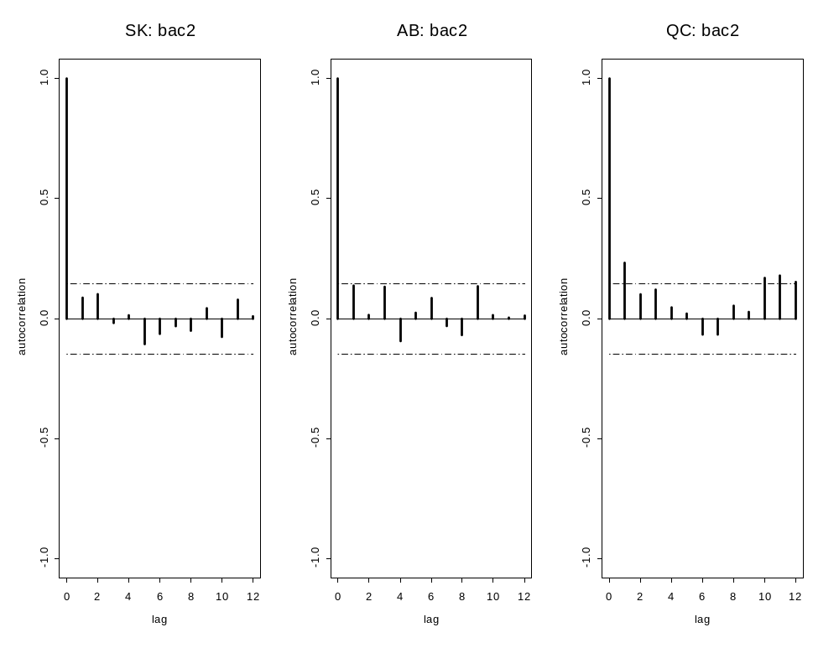
(e) bac3 Fatalities

Saskatchewan: bac3 Fatalities

The overall trend is downward but it is only statistically significant on a one-sided test at the 3% level.

> deathsSK <- ts(fatal.df$bac3[fatal.df$province == "SK"], freq = 12, start = 1987)
> deathsSK
Jan Feb Mar Apr May Jun Jul Aug Sep Oct Nov Dec
1987: 1 3 4 0 5 10 4 8 1 5 7 5
1988: 3 2 1 4 6 6 3 2 2 5 1 0
1989: 2 4 1 8 6 2 3 6 5 7 5 0
1990: 3 4 3 0 2 3 5 3 5 4 4 0
1991: 2 0 4 4 6 5 2 4 2 2 1 1
1992: 3 1 2 3 3 1 3 3 2 5 2 1
1993: 1 1 4 3 3 5 3 2 6 2 2 2
1994: 1 0 0 3 3 0 4 5 1 4 0 0
1995: 1 2 4 1 3 6 4 6 1 5 0 2
1996: 3 2 3 1 1 3 1 4 5 2 0 1
1997: 0 2 2 1 4 2 1 0 3 1 2 4
1998: 0 3 1 6 4 0 4 3 1 2 2 4
1999: 2 2 2 9 6 3 4 2 3 2 3 2
2000: 1 1 0 3 2 0 5 3 3 4 0 1
2001: 4 0 3 1 2 3 5 6 4 4 6 1
> SeasonalMannKendall(deathsSK)
tau = -0.112, sl =5.765%

Alberta: bac3 Fatalities

The overall trend is downward and it is statistically significant at about 0.0003 on a two-sided test.

deathsAB <- ts(fatal.df$bac3[fatal.df$province == "AB"], freq = 12, start = 1987)
> deathsAB
Jan Feb Mar Apr May Jun Jul Aug Sep Oct Nov Dec
1987: 7 2 8 10 11 9 6 12 11 11 8 11
1988: 4 5 12 12 8 7 13 8 8 10 8 7
1989: 3 4 4 9 5 7 14 10 12 13 8 6
1990: 5 1 10 3 9 5 9 7 9 2 3 4
1991: 7 5 5 4 9 2 11 11 8 9 2 7
1992: 6 3 7 7 6 3 5 14 4 5 3 5
1993: 1 4 2 2 6 5 4 4 8 9 7 3
1994: 0 4 5 4 8 6 11 7 11 6 7 4
1995: 3 3 5 4 8 5 5 8 4 15 3 2
1996: 4 0 5 4 3 6 8 10 6 6 3 6
1997: 3 2 5 6 6 4 8 6 5 6 8 8
1998: 2 2 1 3 11 5 7 6 6 11 7 14
1999: 3 1 6 2 8 6 7 7 2 5 8 7
2000: 1 5 4 7 4 8 7 4 7 9 4 3
2001: 4 4 6 8 4 6 6 11 10 9 7 5
> SeasonalMannKendall(deathsAB)
tau = -0.21, sl =0.02757%

Quebec: bac3 Fatalities

The overall trend is downward and it is statistically significant at about 10⁻¹¹ on a two-sided test.

deathsQC <- ts(fatal.df$bac3[fatal.df$province == "QC"], freq = 12, start = 1987)
> deathsQC
Jan Feb Mar Apr May Jun Jul Aug Sep Oct Nov Dec
1987: 6 4 3 7 17 20 19 22 18 19 13 9
1988: 11 2 7 14 22 29 22 19 15 16 14 15
1989: 3 13 14 17 14 20 31 15 26 17 22 9
1990: 8 7 12 14 25 22 23 20 13 8 8 8
1991: 9 8 19 13 26 25 23 23 14 9 8 5
1992: 6 11 6 13 17 22 13 15 12 9 13 17
1993: 2 9 6 12 19 19 23 15 13 15 3 12
1994: 4 0 3 12 7 8 17 13 17 23 12 12
1995: 4 7 6 12 18 18 16 15 12 14 14 6
1996: 8 8 11 6 11 14 10 21 11 14 15 13
1997: 10 4 1 11 13 13 14 14 6 8 10 4
1998: 7 5 6 6 10 6 8 15 9 12 14 12
1999: 6 7 5 8 4 10 10 6 4 12 5 8
2000: 6 7 5 4 9 11 10 15 11 8 8 7
2001: 8 4 4 6 12 8 7 11 9 5 6 6
> SeasonalMannKendall(deathsQC)
tau = -0.421, sl =1.368e-11%

Time Series Plots of bac3 Fatalities

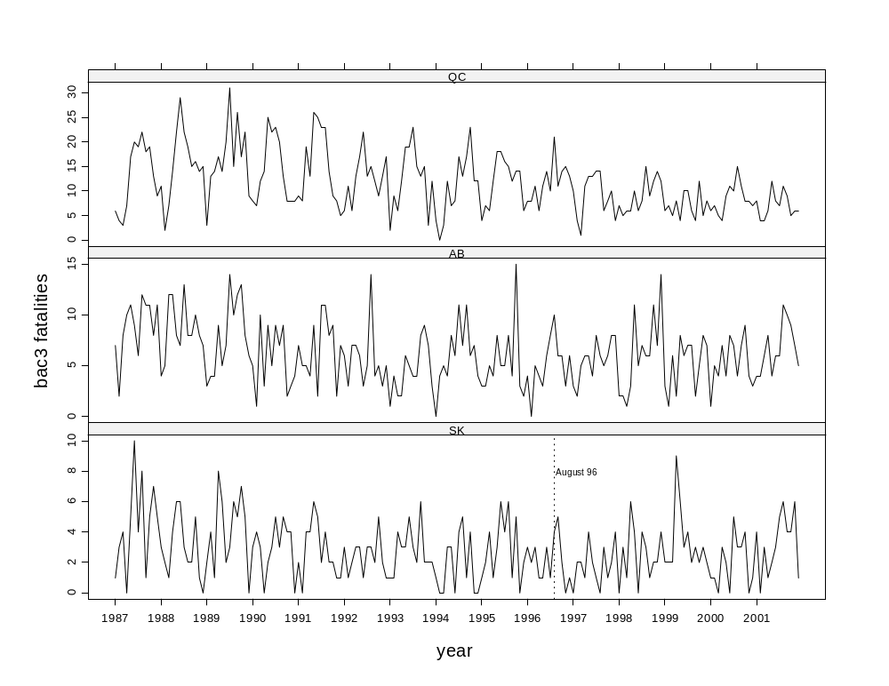

Autocorrelation Analysis

SK has small positive correlations at lags 1 and 12. AB larger correlation at lags 1 and 12 and QC moderately large at lags 1 and 12.

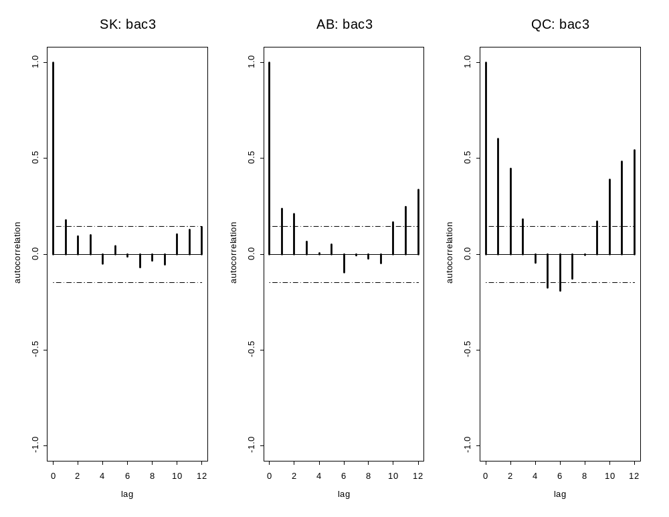
(f) bac4 Fatalities

Saskatchewan: Total Fatalities

The overall trend is downward. It is statistically significant on a two-sided test at the 0.001867 level.

> deathsSK <- ts(fatal.df$bac4[fatal.df$province == "SK"], freq = 12, start = 1987)
> deathsSK
Jan Feb Mar Apr May Jun Jul Aug Sep Oct Nov Dec
1987: 1 6 4 0 6 11 4 8 2 5 8 5
1988: 4 2 1 5 6 7 4 4 3 7 1 0
1989: 2 4 1 8 6 2 3 7 7 8 5 0
1990: 3 4 3 0 2 4 5 3 5 4 4 0
1991: 2 0 4 4 6 5 4 4 4 2 2 1
1992: 3 1 4 4 3 1 3 4 2 5 2 1
1993: 1 1 4 4 3 5 4 3 6 3 2 2
1994: 1 0 0 3 3 0 5 6 2 5 0 1
1995: 1 2 4 1 3 7 5 6 1 6 0 2
1996: 4 2 3 1 1 3 1 4 5 2 0 1
1997: 0 2 2 1 5 2 1 0 3 2 3 4
1998: 1 3 1 6 4 0 4 3 2 2 2 4
1999: 2 3 2 10 6 3 4 2 4 3 4 2
2000: 1 1 0 3 2 0 6 3 3 4 0 1
2001: 4 0 3 2 2 3 6 8 4 4 6 1
> SeasonalMannKendall(deathsSK)
tau = -0.138, sl =1.867%

Alberta: bac4 Fatalities

The overall trend is downward and it is statistically significant at about 0.00008 on a two-sided test.

deathsAB <- ts(fatal.df$bac4[fatal.df$province == "AB"], freq = 12, start = 1987)
> deathsAB
Jan Feb Mar Apr May Jun Jul Aug Sep Oct Nov Dec
1987: 7 2 9 11 12 13 7 12 11 13 10 11
1988: 4 6 12 14 9 7 15 9 9 11 8 7
1989: 3 6 4 9 6 7 14 10 12 14 10 6
1990: 5 2 10 4 12 6 10 10 10 3 3 4
1991: 7 6 6 4 11 3 12 13 8 9 3 7
1992: 7 4 7 8 8 3 6 14 5 6 4 7
1993: 3 5 2 2 6 7 4 4 8 9 9 3
1994: 1 4 5 4 9 7 11 8 12 7 7 5
1995: 4 3 6 4 8 5 6 9 4 15 3 2
1996: 4 1 5 4 4 6 8 10 6 6 3 6
1997: 3 2 5 6 7 5 9 7 6 6 8 9
1998: 2 4 3 5 13 7 7 6 7 11 8 14
1999: 3 1 6 2 10 7 8 7 2 5 8 8
2000: 1 5 4 7 4 8 8 6 7 10 5 3
2001: 6 4 6 9 6 6 7 12 10 10 7 5
> SeasonalMannKendall(deathsAB)
tau = -0.226, sl =0.008244%

Quebec: bac4 Fatalities

The overall trend is downward and it is statistically significant at about 10⁻¹⁰ on a two-sided test.

deathsQC <- ts(fatal.df$bac4[fatal.df$province == "QC"], freq = 12, start = 1987)
> deathsQC
Jan Feb Mar Apr May Jun Jul Aug Sep Oct Nov Dec
1987: 6 4 3 7 19 23 19 24 20 22 14 11
1988: 12 2 8 16 24 31 25 22 15 18 15 16
1989: 3 14 14 18 18 24 33 16 28 19 22 10
1990: 8 8 13 17 28 24 26 21 16 10 8 10
1991: 12 10 21 14 29 28 23 24 15 9 9 6
1992: 6 13 6 14 18 24 13 16 12 9 14 18
1993: 2 11 6 13 20 21 23 16 14 17 3 12
1994: 4 0 4 12 9 10 17 13 17 25 13 12
1995: 6 8 7 14 18 20 18 16 13 14 16 8
1996: 8 8 12 7 11 14 10 22 11 16 16 13
1997: 10 4 1 12 13 14 15 18 8 8 11 5
1998: 9 6 8 6 11 8 8 16 9 12 15 12
1999: 6 7 5 10 6 11 14 8 4 14 6 10
2000: 6 7 6 7 11 13 12 17 12 9 10 8
2001: 8 4 4 7 12 10 9 11 10 5 6 7
> SeasonalMannKendall(deathsQC)
tau = -0.402, sl =1.368e-10%

Time Series Plots of bac4 Fatalities

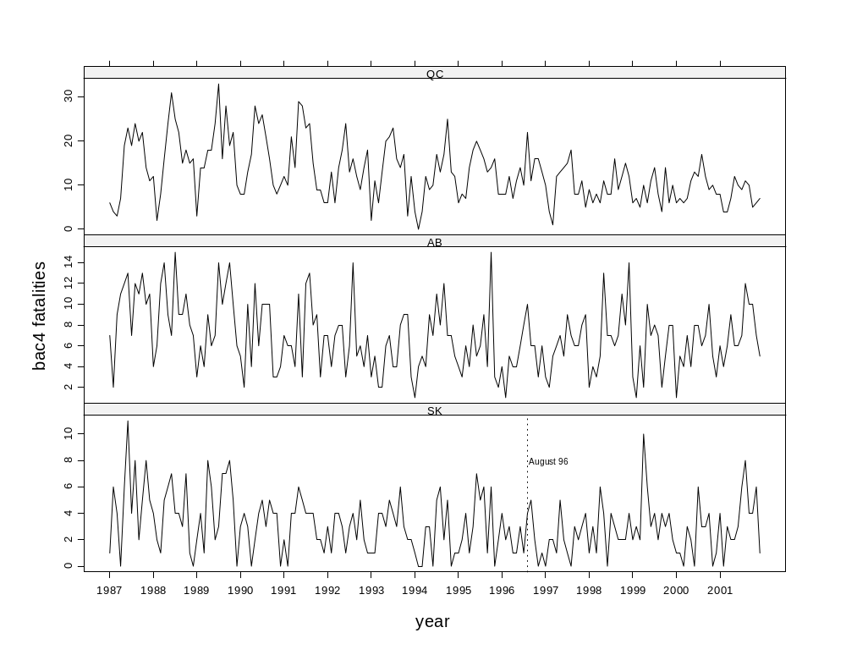

Autocorrelation Analysis

Small positive autocorrelation at lags 1 and 12 in SK. Slightly larger in AB and moderately large in QC.

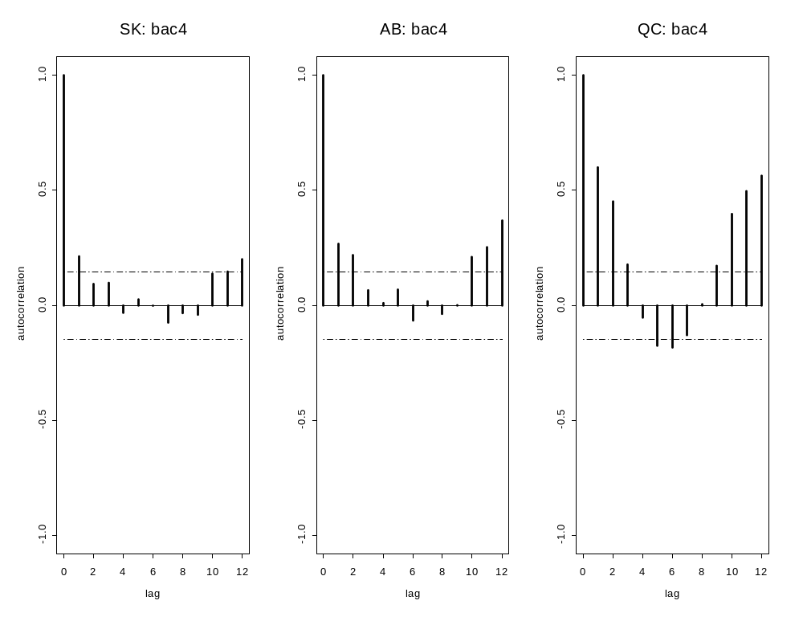
(g) noalc Fatalities

Saskatchewan: noalc Fatalities

No significant trend.

> deathsSK <- ts(fatal.df$noalc[fatal.df$province == "SK"], freq = 12, start = 1987)
> deathsSK
Jan Feb Mar Apr May Jun Jul Aug Sep Oct Nov Dec
1987: 3 1 4 1 5 6 5 5 4 4 3 1
1988: 2 4 6 2 1 7 8 4 3 6 5 7
1989: 9 2 5 2 5 5 6 4 5 9 2 4
1990: 2 4 1 2 6 6 4 5 6 8 4 2
1991: 0 4 4 3 5 3 5 6 2 3 2 6
1992: 4 3 4 6 4 3 3 3 2 2 3 2
1993: 4 3 4 9 5 3 7 3 2 7 5 4
1994: 7 2 1 0 6 6 14 4 2 6 4 3
1995: 5 4 1 1 4 6 7 8 4 2 4 5
1996: 3 2 2 3 4 2 2 3 6 2 4 9
1997: 4 3 4 2 3 3 3 2 5 4 5 7
1998: 2 6 2 4 7 5 9 2 4 3 5 3
1999: 3 4 5 4 4 5 0 5 3 6 5 6
2000: 6 2 3 7 7 3 5 4 2 3 4 5
2001: 1 3 3 3 4 8 3 6 6 4 3 4
> SeasonalMannKendall(deathsSK)
tau = 0.00343, sl =95.32%

Alberta: noalc Fatalities

No significant trend.

deathsAB <- ts(fatal.df$noalc[fatal.df$province == "AB"], freq = 12, start = 1987)
> deathsAB
Jan Feb Mar Apr May Jun Jul Aug Sep Oct Nov Dec
1987: 9 8 11 13 16 9 17 20 15 6 18 4
1988: 8 10 11 8 10 16 14 21 18 17 2 12
1989: 7 13 7 7 9 8 16 16 16 13 14 20
1990: 14 9 10 10 5 11 12 13 12 12 13 10
1991: 7 11 9 6 7 10 17 13 12 8 17 9
1992: 4 5 9 7 6 15 9 13 14 8 8 14
1993: 10 7 10 7 8 9 14 18 13 13 15 16
1994: 15 7 7 9 17 16 14 12 17 10 15 14
1995: 13 10 4 17 14 11 14 13 15 14 16 10
1996: 12 6 9 11 6 5 13 17 10 10 12 17
1997: 9 9 19 15 11 7 11 22 12 21 16 17
1998: 11 13 12 10 13 14 11 18 12 11 16 15
1999: 11 9 16 7 15 14 7 9 11 16 13 14
2000: 0 12 8 5 9 8 19 10 13 7 18 14
2001: 17 8 6 10 13 18 9 19 13 10 10 7
> SeasonalMannKendall(deathsAB)
tau = -0.0328, sl =56.39%

Quebec: noalc Fatalities

The overall trend is downward and it is statistically significant at about 10⁻³ on a two-sided test.

deathsQC <- ts(fatal.df$noalc[fatal.df$province == "QC"], freq = 12, start = 1987)
> deathsQC
Jan Feb Mar Apr May Jun Jul Aug Sep Oct Nov Dec
1987: 7 4 2 3 9 6 15 10 7 6 11 16
1988: 14 7 8 9 12 16 26 16 6 21 12 16
1989: 16 15 12 17 17 14 26 24 16 14 13 16
1990: 9 16 17 12 7 29 22 23 21 23 19 15
1991: 20 22 10 10 15 14 24 20 14 12 17 16
1992: 19 16 11 10 19 20 16 26 13 22 15 35
1993: 27 19 20 12 13 31 33 25 20 27 18 19
1994: 22 13 9 13 20 19 22 25 18 20 10 15
1995: 26 17 16 9 19 23 20 23 19 17 27 11
1996: 23 19 19 6 18 21 20 35 13 23 19 15
1997: 18 9 15 8 9 18 13 26 13 19 24 16
1998: 12 11 8 16 12 17 24 18 17 15 16 18
1999: 18 16 15 19 26 28 27 24 26 22 27 17
2000: 15 19 12 15 26 22 17 28 23 24 14 14
2001: 18 13 13 8 14 21 20 26 15 9 6 18
> SeasonalMannKendall(deathsQC)
tau = 0.182, sl =0.1272%

Time Series Plots of noalc Fatalities

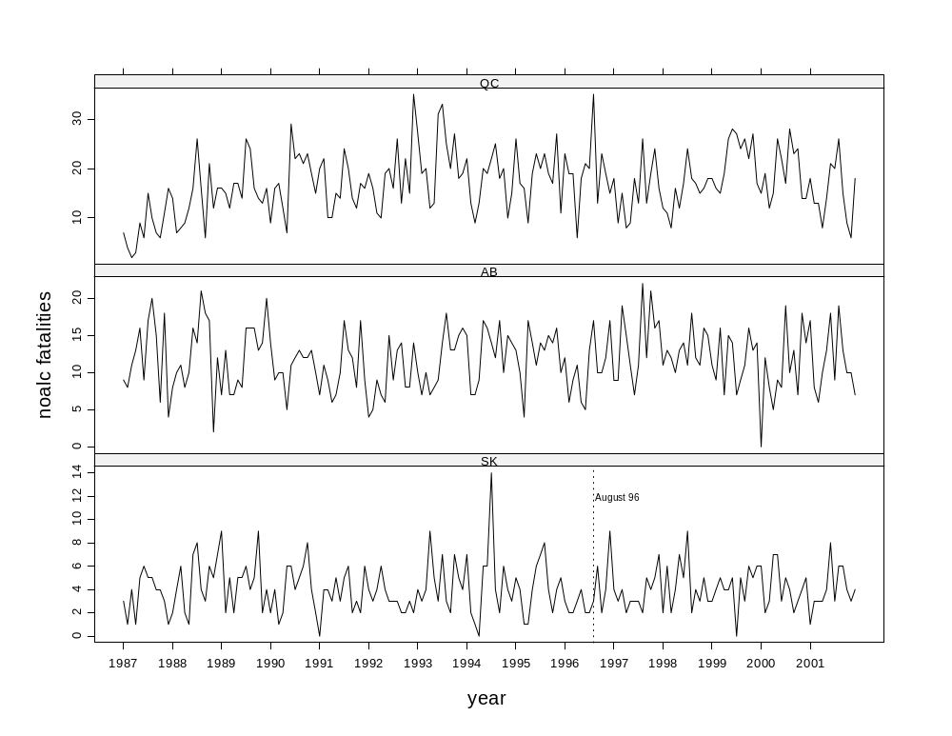

Autocorrelation Analysis

SK shows no significant autocorrelation but small positive autocorrelations are present at lags 1 and 12. AL very small autocorrelations at lags 1 and 12. QC shows moderate autocorrelation at lags 1 and 12.

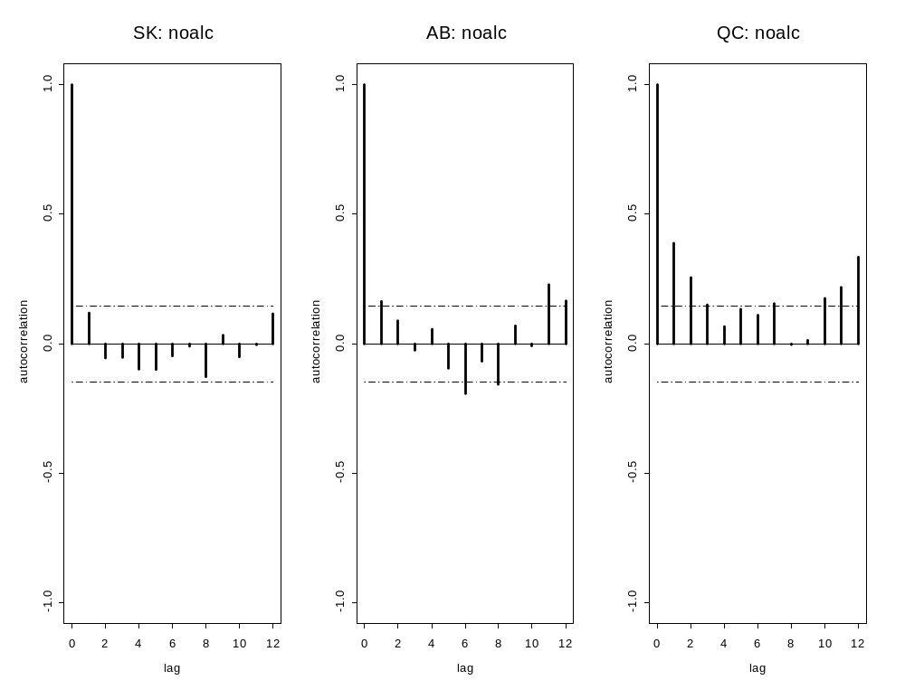
(h) alc Fatalities

Saskatchewan: alc Fatalities

The overall trend is downward. It is statistically significant on a two-sided test at the 0.0059 level.

> deathsSK <- ts(fatal.df$alc[fatal.df$province == "SK"], freq = 12, start = 1987)
> deathsSK
Jan Feb Mar Apr May Jun Jul Aug Sep Oct Nov Dec
1987: 1 6 4 0 6 11 4 8 2 6 8 6
1988: 6 2 1 5 7 8 4 5 3 8 1 0
1989: 3 4 1 8 6 2 5 7 7 9 5 1
1990: 3 4 3 0 3 5 5 3 6 5 4 1
1991: 2 1 5 4 7 5 6 5 4 3 2 2
1992: 3 1 4 4 3 1 4 4 2 5 2 1
1993: 1 1 5 4 3 5 6 3 6 4 2 2
1994: 1 0 0 3 3 2 6 7 3 5 0 3
1995: 5 2 4 1 3 8 5 7 1 6 0 2
1996: 4 2 3 1 1 3 1 6 6 2 0 1
1997: 0 2 2 1 6 3 1 0 3 2 3 4
1998: 1 3 1 6 4 0 4 3 2 2 2 4
1999: 2 3 2 10 6 3 4 2 5 5 4 2
2000: 1 1 0 3 2 0 7 3 3 4 1 1
2001: 5 0 3 2 4 3 6 8 5 4 7 1
> SeasonalMannKendall(deathsSK)
tau = -0.16, sl =0.5891%

Alberta: alc Fatalities

The overall trend is downward and it is statistically significant at about 0.01% on a two-sided test.

deathsAB <- ts(fatal.df$alc[fatal.df$province == "AB"], freq = 12, start = 1987)
> deathsAB
Jan Feb Mar Apr May Jun Jul Aug Sep Oct Nov Dec
1987: 7 3 10 11 13 14 8 12 12 13 12 11
1988: 4 6 12 19 9 8 16 12 9 12 9 7
1989: 5 6 4 9 6 8 16 10 13 14 10 6
1990: 5 3 10 4 12 7 10 11 12 3 3 5
1991: 7 6 6 4 12 4 13 15 8 9 3 7
1992: 8 4 7 10 9 6 7 15 5 7 4 7
1993: 3 5 2 2 7 9 5 7 10 10 10 3
1994: 1 4 5 5 9 7 11 9 13 7 7 6
1995: 5 4 6 5 8 6 6 9 7 15 3 2
1996: 4 2 5 5 7 8 8 10 6 7 4 8
1997: 3 2 6 6 7 7 10 7 7 7 9 11
1998: 2 4 3 5 14 7 8 7 7 12 11 14
1999: 3 2 7 2 10 9 8 9 2 5 8 8
2000: 1 5 4 8 4 9 8 6 10 11 6 4
2001: 6 4 6 10 6 7 7 13 10 10 7 5
> SeasonalMannKendall(deathsAB)
tau = -0.22, sl =0.01334%

Quebec: alc Fatalities

The overall trend is downward and it is statistically significant at about 10⁻¹² on a two-sided test.

deathsQC <- ts(fatal.df$alc[fatal.df$province == "QC"], freq = 12, start = 1987)
> deathsQC
Jan Feb Mar Apr May Jun Jul Aug Sep Oct Nov Dec
1987: 11 6 4 16 21 31 25 32 23 24 15 11
1988: 13 4 10 17 27 32 27 25 16 20 17 17
1989: 3 15 14 20 18 27 35 17 29 20 22 12
1990: 9 9 16 20 30 26 30 22 18 13 8 10
1991: 12 13 22 15 32 29 25 24 16 12 9 6
1992: 10 15 7 14 21 27 14 19 13 11 14 21
1993: 3 12 6 14 20 24 25 17 17 17 6 13
1994: 9 1 6 12 12 10 20 14 19 29 16 12
1995: 8 9 8 16 20 22 19 18 14 14 16 10
1996: 9 10 12 7 12 14 15 22 11 20 17 14
1997: 11 6 1 13 13 14 17 20 9 8 12 6
1998: 10 6 8 6 12 10 8 16 10 13 16 14
1999: 7 7 7 10 6 14 15 9 4 14 6 11
2000: 7 7 8 7 12 14 14 18 14 10 10 9
2001: 10 4 4 8 16 13 9 11 11 8 6 7
> SeasonalMannKendall(deathsQC)
tau = -0.437, sl =1.288e-12%

Time Series Plots of alc Fatalities

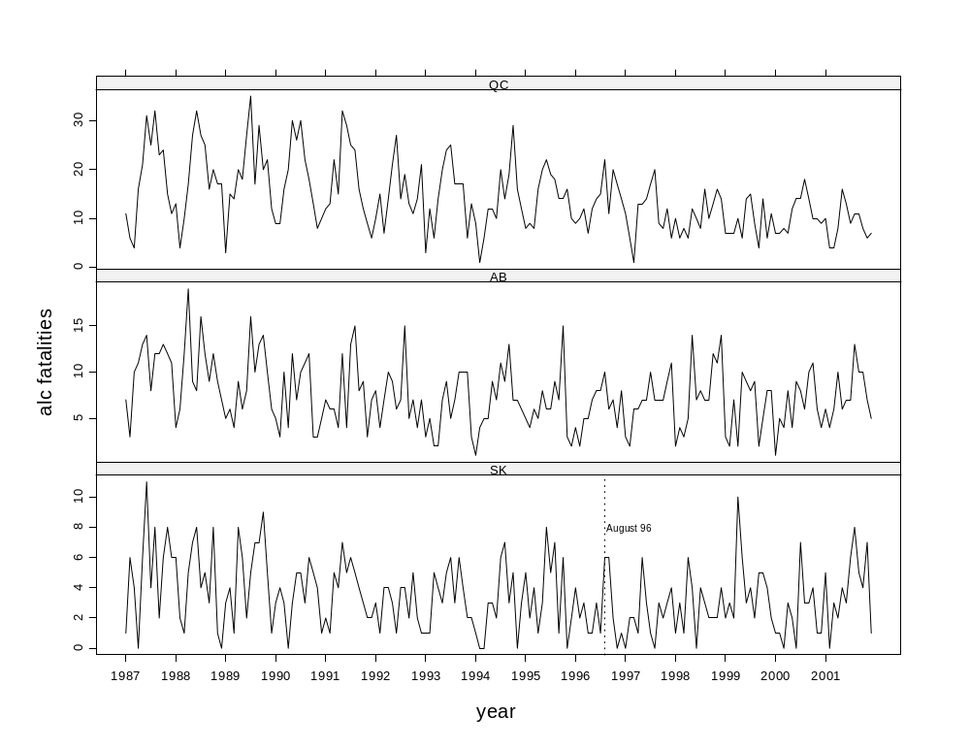

Autocorrelation Analysis

SK shows small positive autocorrelations are present at lags 1 and 12. AL moderate positive autocorrelations at lags 1 and 12. QC shows strong autocorrelation at lags 1 and 12.

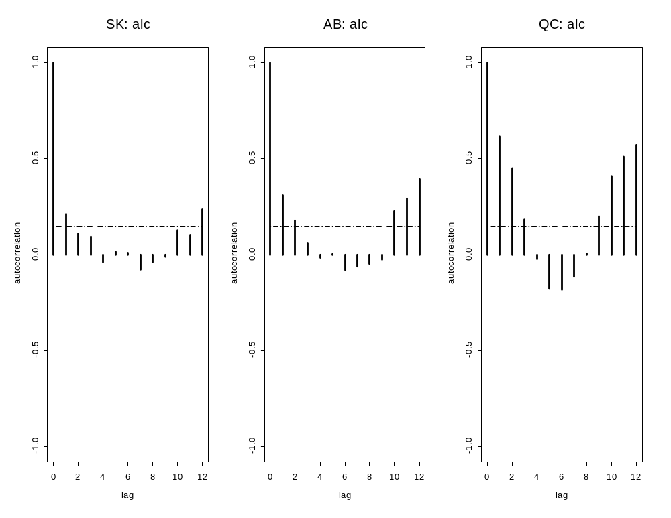
(i) ratio

Saskatchewan: ratio

The overall trend is downward but it is only statistically significant on a two-sided test at the 2% level.
> deathsSK <- ts(fatal.df$ratio[fatal.df$province == "SK"], freq = 12, start = 1987)
> round(deathsSK, 3)
Jan Feb Mar Apr May Jun Jul Aug Sep Oct Nov Dec
1987: 0.333 6.000 1.000 0.000 1.200 1.833 0.800 1.600 0.500 1.250 2.667 5.000
1988: 2.000 0.500 0.167 2.500 6.000 1.000 0.500 1.000 1.000 1.167 0.200 0.000
1989: 0.222 2.000 0.200 4.000 1.200 0.400 0.500 1.750 1.400 0.889 2.500 0.000
1990: 1.500 1.000 3.000 0.000 0.333 0.667 1.250 0.600 0.833 0.500 1.000 0.000
1991: NA 0.000 1.000 1.333 1.200 1.667 0.800 0.667 2.000 0.667 1.000 0.167
1992: 0.750 0.333 1.000 0.667 0.750 0.333 1.000 1.333 1.000 2.500 0.667 0.500
1993: 0.250 0.333 1.000 0.444 0.600 1.667 0.571 1.000 3.000 0.429 0.400 0.500
1994: 0.143 0.000 0.000 NA 0.500 0.000 0.357 1.500 1.000 0.833 0.000 0.333
1995: 0.200 0.500 4.000 1.000 0.750 1.167 0.714 0.750 0.250 3.000 0.000 0.400
1996: 1.333 1.000 1.500 0.333 0.250 1.500 0.500 1.333 0.833 1.000 0.000 0.111
1997: 0.000 0.667 0.500 0.500 1.667 0.667 0.333 0.000 0.600 0.500 0.600 0.571
1998: 0.500 0.500 0.500 1.500 0.571 0.000 0.444 1.500 0.500 0.667 0.400 1.333
1999: 0.667 0.750 0.400 2.500 1.500 0.600 NA 0.400 1.333 0.500 0.800 0.333
2000: 0.167 0.500 0.000 0.429 0.286 0.000 1.200 0.750 1.500 1.333 0.000 0.200
2001: 4.000 0.000 1.000 0.667 0.500 0.375 2.000 1.333 0.667 1.000 2.000 0.250
> SeasonalMannKendall(deathsSK)
tau = -0.134, sl =1.893%
> #SacfPlot(deathsSK, maxlag=12)

Alberta: ratio

The overall trend is downward and it is statistically significant at about 0.3% on a two-sided test.

deathsAB <- ts(fatal.df$ratio[fatal.df$province == "AB"], freq = 12, start = 1987)
> round(deathsAB, 3)
Jan Feb Mar Apr May Jun Jul Aug Sep Oct Nov Dec
1987: 0.778 0.250 0.818 0.846 0.750 1.444 0.412 0.600 0.733 2.167 0.556 2.750
1988: 0.500 0.600 1.091 1.750 0.900 0.438 1.071 0.429 0.500 0.647 4.000 0.583
1989: 0.429 0.462 0.571 1.286 0.667 0.875 0.875 0.625 0.750 1.077 0.714 0.300
1990: 0.357 0.222 1.000 0.400 2.400 0.545 0.833 0.769 0.833 0.250 0.231 0.400
1991: 1.000 0.545 0.667 0.667 1.571 0.300 0.706 1.000 0.667 1.125 0.176 0.778
1992: 1.750 0.800 0.778 1.143 1.333 0.200 0.667 1.077 0.357 0.750 0.500 0.500
1993: 0.300 0.714 0.200 0.286 0.750 0.778 0.286 0.222 0.615 0.692 0.600 0.188
1994: 0.067 0.571 0.714 0.444 0.529 0.438 0.786 0.667 0.706 0.700 0.467 0.357
1995: 0.308 0.300 1.500 0.235 0.571 0.455 0.429 0.692 0.267 1.071 0.188 0.200
1996: 0.333 0.167 0.556 0.364 0.667 1.200 0.615 0.588 0.600 0.600 0.250 0.353
1997: 0.333 0.222 0.263 0.400 0.636 0.714 0.818 0.318 0.500 0.286 0.500 0.529
1998: 0.182 0.308 0.250 0.500 1.000 0.500 0.636 0.333 0.583 1.000 0.500 0.933
1999: 0.273 0.111 0.375 0.286 0.667 0.500 1.143 0.778 0.182 0.312 0.615 0.571
2000: NA 0.417 0.500 1.400 0.444 1.000 0.421 0.600 0.538 1.429 0.278 0.214
2001: 0.353 0.500 1.000 0.900 0.462 0.333 0.778 0.632 0.769 1.000 0.700 0.714
> SeasonalMannKendall(deathsAB)
tau = -0.167, sl =0.283%

Quebec: ratio

The overall trend is downward and it is statistically significant at about 10⁻¹⁴ on a two-sided test.

deathsQC <- ts(fatal.df$ratio[fatal.df$province == "QC"], freq = 12, start = 1987)
> round(deathsQC, 3)
Jan Feb Mar Apr May Jun Jul Aug Sep Oct Nov Dec
1987: 0.857 1.000 1.500 2.333 2.111 3.833 1.267 2.400 2.857 3.667 1.273 0.688
1988: 0.857 0.286 1.000 1.778 2.000 1.938 0.962 1.375 2.500 0.857 1.250 1.000
1989: 0.188 0.933 1.167 1.059 1.059 1.714 1.269 0.667 1.750 1.357 1.692 0.625
1990: 0.889 0.500 0.765 1.417 4.000 0.828 1.182 0.913 0.762 0.435 0.421 0.667
1991: 0.600 0.455 2.100 1.400 1.933 2.000 0.958 1.200 1.071 0.750 0.529 0.375
1992: 0.316 0.812 0.545 1.400 0.947 1.200 0.812 0.615 0.923 0.409 0.933 0.514
1993: 0.074 0.579 0.300 1.083 1.538 0.677 0.697 0.640 0.700 0.630 0.167 0.632
1994: 0.182 0.000 0.444 0.923 0.450 0.526 0.773 0.520 0.944 1.250 1.300 0.800
1995: 0.231 0.471 0.438 1.556 0.947 0.870 0.900 0.696 0.684 0.824 0.593 0.727
1996: 0.348 0.421 0.632 1.167 0.611 0.667 0.500 0.629 0.846 0.696 0.842 0.867
1997: 0.556 0.444 0.067 1.500 1.444 0.778 1.154 0.692 0.615 0.421 0.458 0.312
1998: 0.750 0.545 1.000 0.375 0.917 0.471 0.333 0.889 0.529 0.800 0.938 0.667
1999: 0.333 0.438 0.333 0.526 0.231 0.393 0.519 0.333 0.154 0.636 0.222 0.588
2000: 0.400 0.368 0.500 0.467 0.423 0.591 0.706 0.607 0.522 0.375 0.714 0.571
2001: 0.444 0.308 0.308 0.875 0.857 0.476 0.450 0.423 0.667 0.556 1.000 0.389
> SeasonalMannKendall(deathsQC)
tau = -0.457, sl =2.22e-14%

Time Series Plots of ratio Fatalities

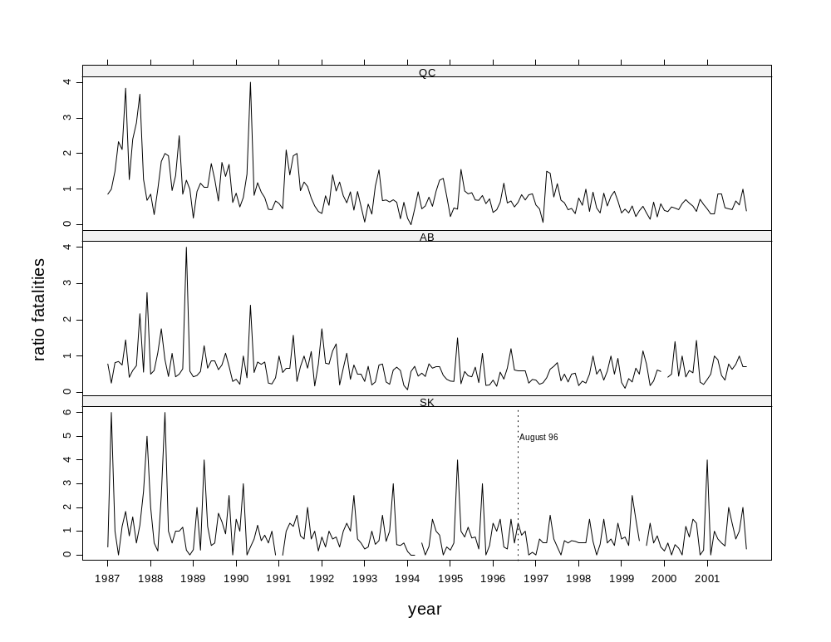

Autocorrelation Analysis

SK shows no important autocorrelation. AL very small autocorrelation at lag 12. QC shows moderate autocorrelation at lags 1 and 12.

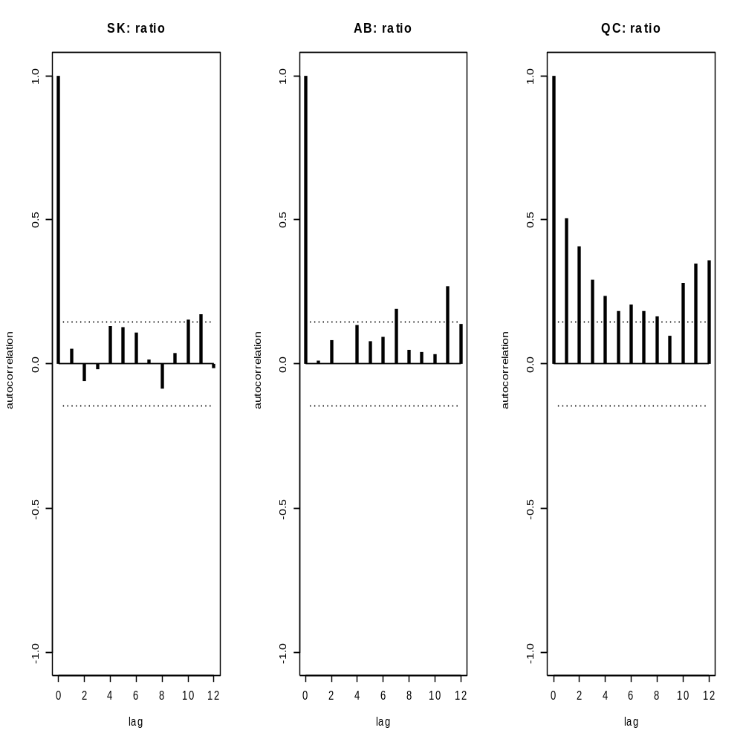
(j) unemploy

Saskatchewan: unemployment rate

> unemploySK <- ts(fatal.df$unemploy[fatal.df$province == "SK"], freq = 12, start = 1987)
> summary(unemploySK)
Min. 1st Qu. Median Mean 3rd Qu. Max.
4.400 5.800 6.700 6.752 7.600 10.100

Alberta: unemployment rate

unemployAB <- ts(fatal.df$unemploy[fatal.df$province == "AB"], freq = 12, start = 1987)
> summary(unemployAB)
Min. 1st Qu. Median Mean 3rd Qu. Max.
3.600 5.800 7.200 7.241 8.425 11.500

Quebec: unemployment rate

unemployQC <- ts(fatal.df$unemploy[fatal.df$province == "QC"], freq = 12, start = 1987)
> summary(unemployQC)
Min. 1st Qu. Median Mean 3rd Qu. Max.
7.60 9.30 10.70 10.78 11.93 15.00

Time Series Plots of unemployment rate

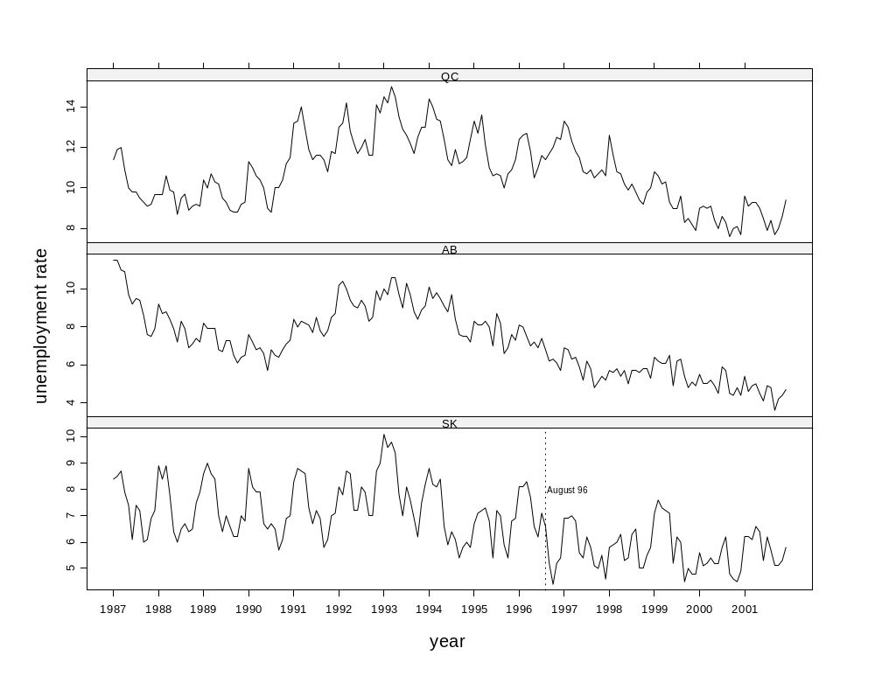

(k) numlicen

Saskatchewan: Number of Licensed Drivers

> numlicenSK <- ts(fatal.df$numlicen[fatal.df$province == "SK"], freq = 12, start = 1987)
> summary(numlicenSK)
Min. 1st Qu. Median Mean 3rd Qu. Max.
624964 640428 647786 650239 662810 667378

Alberta: Number of Licensed Drivers

numlicenAB <- ts(fatal.df$numlicen[fatal.df$province == "AB"], freq = 12, start = 1987)
> summary(numlicenAB)
Min. 1st Qu. Median Mean 3rd Qu. Max.
653822 664564 675659 679460 692941 710456

Quebec: Number of Licensed Drivers

numlicenQC <- ts(fatal.df$numlicen[fatal.df$province == "QC"], freq = 12, start = 1987)
> summary(numlicenQC)
Min. 1st Qu. Median Mean 3rd Qu. Max.
3771792 4032971 4212592 4203660 4402692 4545461

Time Series Plots of number of licensed drivers

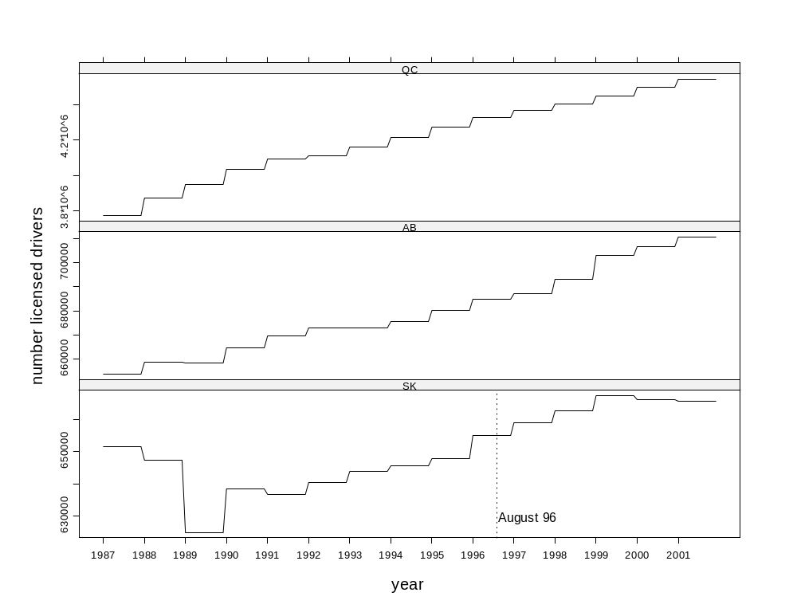

(l) rbac2 Fatalities

rbac2 = bac2 fatality rate per 100,000 drivers
The table below shows that the bac2 variable is basically just small counts:
> table(deathsSK)
0 1 2 3
131 41 7 1

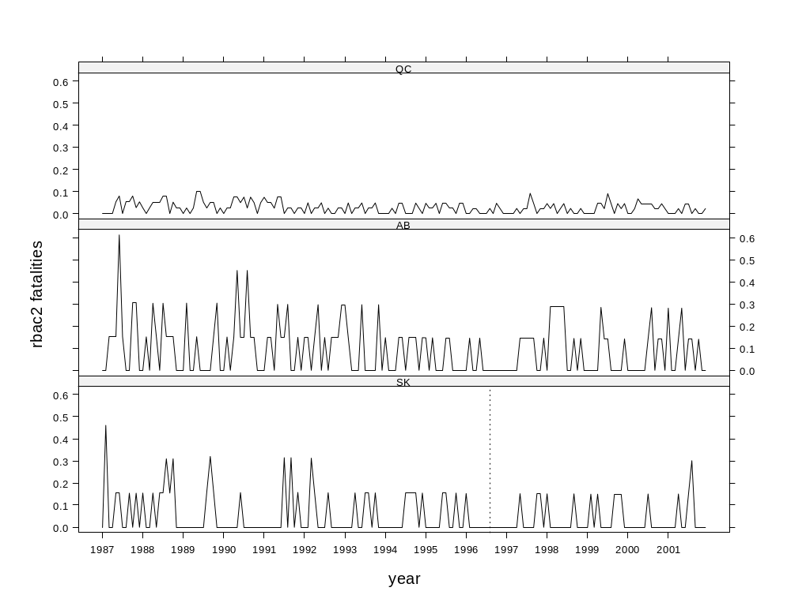

> SeasonalMannKendall(deathsSK)
tau = -0.171, sl =0.7064%
> SeasonalMannKendall(deathsAB)
tau = -0.246, sl =0.003419%
> SeasonalMannKendall(deathsQC)
tau = -0.334, sl =6.516e-7%

Definite monotonic trend in SK, AB and QC rates.

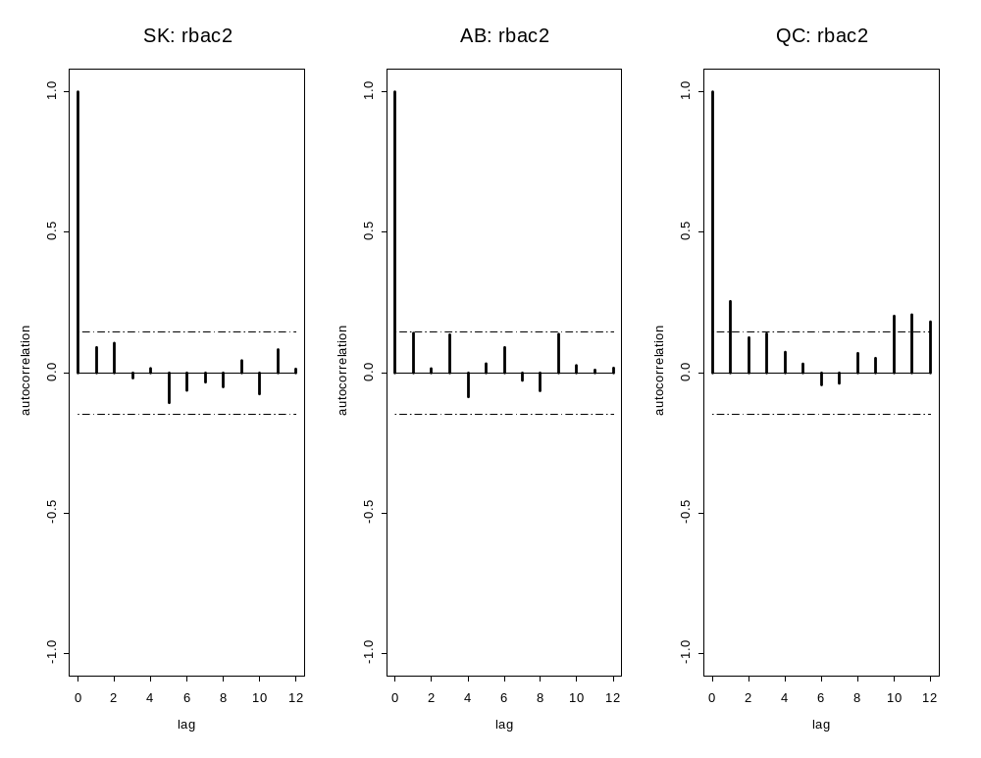No significant autocorrelation in SK. Very small autocorrelation in AB at lag one. Small positive autocorrelation in QC at lags one and twelve.

(m) rbac4 Fatalities

rbac4 = bac4 fatality rate per 100,000 drivers

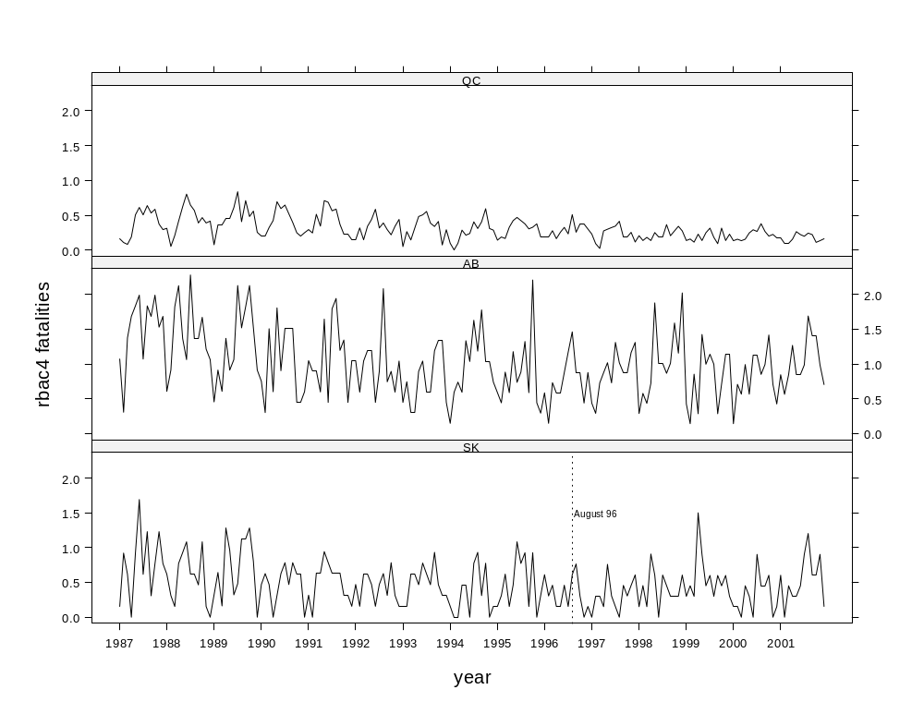

> SeasonalMannKendall(deathsSK)
tau = -0.215, sl =0.01175%
> SeasonalMannKendall(deathsAB)
tau = -0.308, sl =2.976e-6%
> SeasonalMannKendall(deathsQC)
tau = -0.478, sl =0%

Downward trend in SK rbac4 and even stronger downward trends in AB and QC.
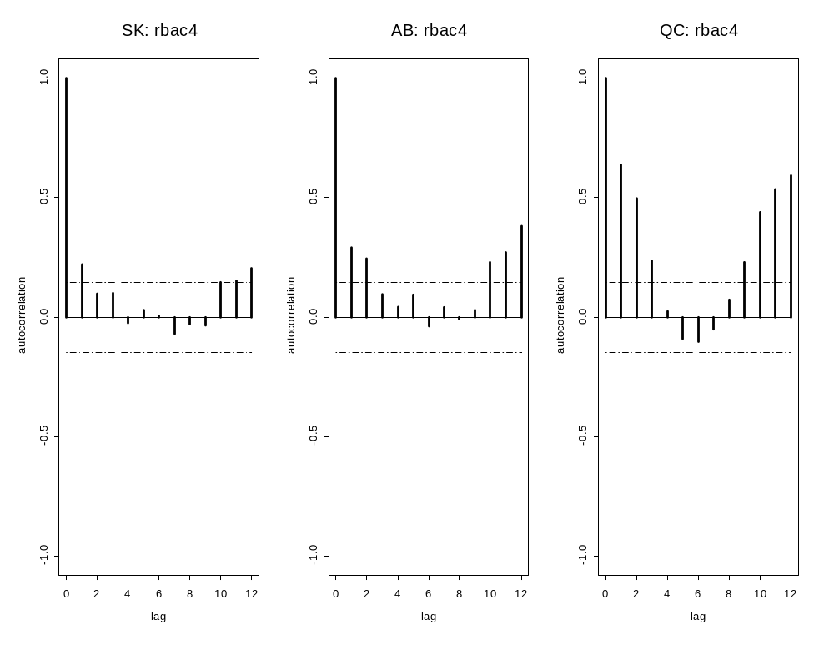

Small positive autocorrelation at lag one and twelve in SK. These autocorrelations are larger in AB and again larger in QC.

(n) ralc Fatalities

ralc = alc fatality rate per 100,000 drivers

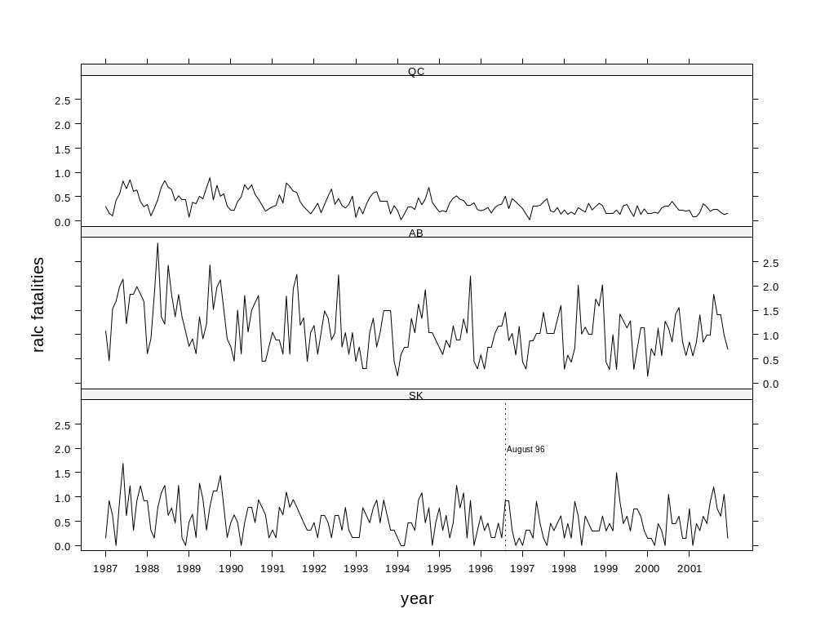

> SeasonalMannKendall(deathsSK)
tau = -0.249, sl =7.644e-4%
> SeasonalMannKendall(deathsAB)
tau = -0.303, sl =4.839e-6%
> SeasonalMannKendall(deathsQC)
tau = -0.508, sl =0%

Strong monotonic downward trend in SK, AB and QC. Downward slope increases from SK to AB and AB to QC.

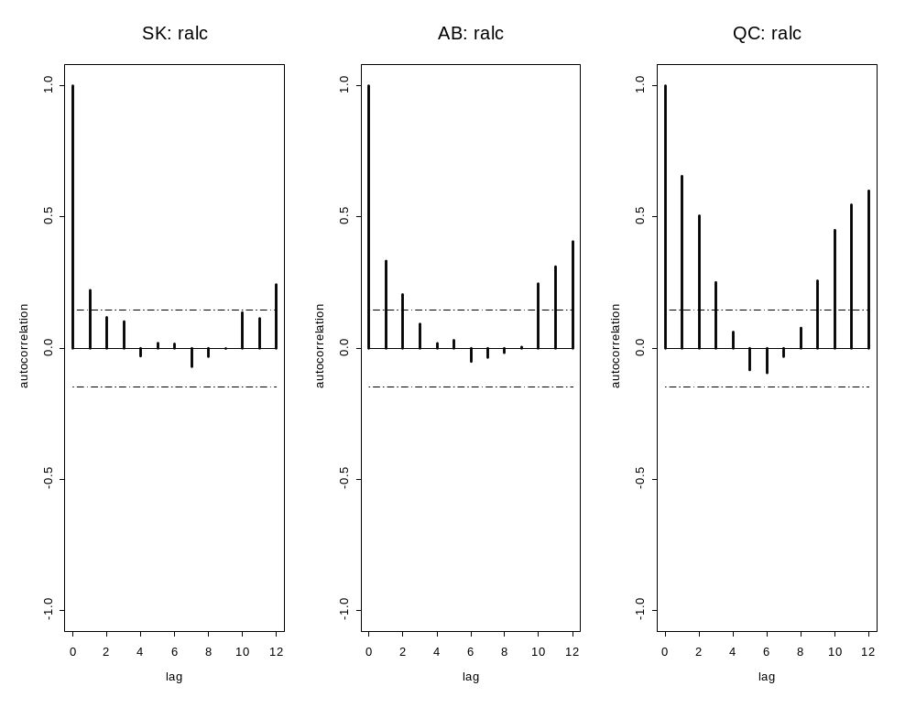

Small positive autocorrelation at lag one and twelve in SK. These autocorrelations are larger in AB and again larger in QC.

(o) rratio Fatalities

rratio = ratio fatality rate per 100,000 drivers

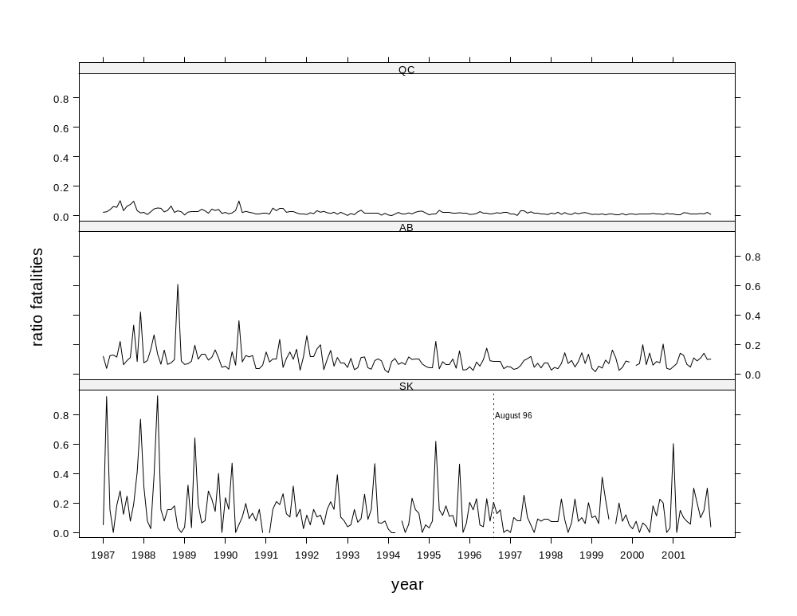

> SeasonalMannKendall(deathsSK)
tau = -0.156, sl =0.56%
> SeasonalMannKendall(deathsAB)
tau = -0.196, sl =0.04438%
> SeasonalMannKendall(deathsQC)
tau = -0.508, sl =0%

Strong monotonic downward trend in SK, AB and QC. Downward slope increases from SK to AB and AB to QC.

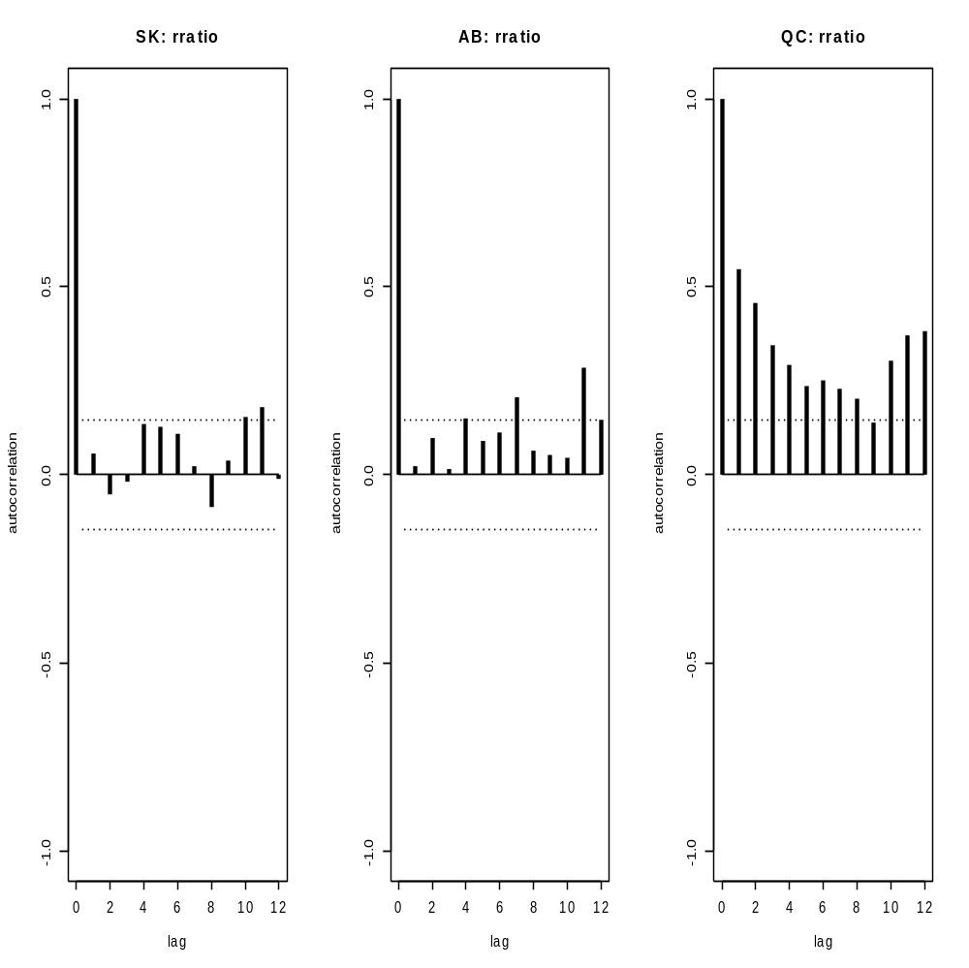

No significant autocorrelation in SK. Possible lag 12 small positive autocorrelation in AB. Moderate autocorrelations at lags 1 and 12 in QC.

